Semantic UAV Disaster Communication: EDA report
Oct 15, 2026 · @karthik
We looked at 1,000 simulated people in a disaster area who each ask a drone (UAV) for one kind of information. This page explains what the data looks like, in plain words.
In short:
- Users bunch into four groups on the map, one for each kind of request.
- Each group needs something different: medical and rescue requests are urgent and need a fast, accurate message, while general information can wait.
- The data is clean, with nothing missing, so it is ready to use.

What is in the data
Each row is one user. For each user we know where they are on a 100 by 100 map, how strong their signal is (0 to 1), how urgent the request is (1 to 3, with 3 the most urgent), what they are asking for (Medical, Rescue, Location or General), how long they can wait for an answer, and how closely the meaning of a message needs to match the original (semantic similarity, 0 to 1).
The data is clean: nothing is missing, there are no duplicates and no odd values. Each request type has between 238 and 256 users, so none is too rare to study.

Where the users are
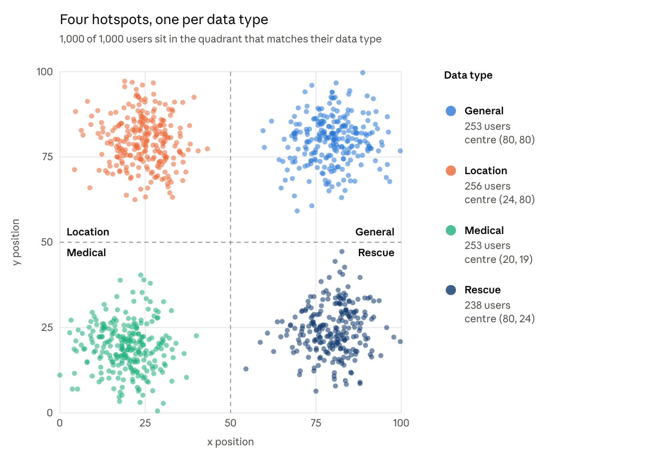
disaster_users.csv · all 1,000 users
Users bunch into four separate groups, one for each type of request. Split the map down the middle and across the middle, and every user lands in the box that matches what they ask for. The groups hardly overlap.

What each group needs
Medical and Rescue users are the most urgent, can wait the least and need the meaning of their message kept closest. General users are the opposite.
Request | Usual priority | Delay allowed (average) | Signal quality (average) | Meaning match (average)
Medical | 3 (highest) | about 1 | 0.83 | 0.90
Rescue | 3 (highest) | about 1.5 | 0.68 | 0.82
Location | 2 (middle) | about 3 | 0.52 | 0.58
General | 1 (lowest) | about 6 | 0.36 | 0.31
Inside a group, users are very alike. So the type of request, more than the individual user, decides how urgent a message is and how fast it must arrive.

